VISVESVARAYA TECHNOLOGICAL UNIVERSITY
"Jnana Sangama", Belgaum: 590018


A Technical Seminar (10CS86)
Report on
Disease prediction using different Data Mining tools
A Technical Seminar report submitted in partial fulfillment of the requirement for the award of the degree of
Bachelor of Engineering
In

Computer Science & Engineering
Submitted by
Ananth Narayan Bhat (1AY14CS018)
Under the guidance of
Dr. P V Kumar

Professor
Department of Computer Science & Engineering

ACHARYA INSTITUTE OF TECHNOLOGY
(Affiliated to Visvesvaraya Technological University, Belgaum)
Soladevanahalli, Bangalore – 560090
2017-2018
ACHARYA INSTITUTE OF TECHNOLOGY
(Affiliated to Visvesvaraya Technological University, Belgaum)
Soladevanahalli, Bangalore – 560090

DEPARTMENT OF COMPUTER SCIENCE & ENGINEERING

CERTIFICATE

Certified that the Technical Seminar Report (10CS86) entitled “Disease prediction using different Data Mining tools” is a bonafide work carried out by Ananth Narayan Bhat (1AY14CS018) in partial fulfillment for the award of degree of Bachelor of Engineering in Computer Science & Engineering of the Visvesvaraya Technological University, Belgaum during the year 2017-2018. This work has been approved as it satisfies the academic requirements for Bachelor of Engineering Degree.

Marks Awarded: Date of Submission of the Report:

Name and Signature of the Guide with Date Signature of the HOD

DECLARATION

I, Ananth Narayan Bhat bearing an USN 1AY14CS018 have submitted the Technical Seminar report entitled “Early Identification of Diseases Based on Responsible Attribute Using Data Mining” to the department library on date 2th April 2018.

Ananth Narayan Bhat (1AY14CS018)

INDEX

CHAPTER NO. TITLE Page No.

1 Introduction | 1
2. Literature survey | 3
3 Work done | 5
3.1 Data mining tools | 6
3.1.1 Weka  3.1.2 Tanagra  3.1.3 Matlab  3.1.4 .NET Framework | 6  7  8  9
3.2 Data mining technique | 10
3.2.1 J48 algorithm  3.2.2 Naïve Bayes algorithm  3.2.3 Fuzzy logic | 10  11  12
3.3 Implementation | 14
4. Applications in medical field | 18
5. Conclusion | 20
6. References | 20

LIST OF FIGURES

Figure No. | Name of the Figure | Page No.
1 | Weka example image | 6
2 | Tanagra example image | 7
3 | Matlab example image | 8
4 | .NET Framework image | 9
5 | J48 algorithm | 10
6 | Naïve Bayes algorithm | 11
7 | Fuzzy Logic | 12
8 | Comparison of Data Mining tools with techniques. | 13
9 | Training data set | 15
10 | User input | 16
11 | Output example | 17

- INTRODUCTION

The advent of high-performance computing has benefited various disciplines in finding practical solutions to their problems, and our health care is no exception to this. Signal processing, image processing, and data mining tools have been developed for effective analysis of medical information, in order to help clinicians in making better diagnosis for treatment purposes.
Data mining has become a fundamental methodology for computing applications in medical informatics. Progress in data mining applications and its implications are manifested in the areas of information management in healthcare organizations, health informatics, epidemiology, patient care and monitoring systems, assistive technology, large-scale image analysis to information extraction and automatic identification of unknown classes. Various algorithms associated with data mining have significantly helped to understand medical data more clearly, by distinguishing pathological data from normal data, for supporting decision-making as well as visualization and identification of hidden complex relationships between diagnostic features of different patient groups. There are nine papers in this Special issue, covering different areas in medical informatics.
Heart disease is a major health problem and it affects a large number of people. In medical, prediction of heart disease is very important. In order to save a patient’s life, lot of effort is being taken by the hospitals and medical practitioner. The health sector today contains hidden information that can be important in making decisions. Diagnosing patients correctly on timely basis is the most challenging task for the medical fraternity. Data mining techniques are used to analyze this rich collection of data from different perspectives and deriving useful information. The objective of this paper is to study the various data mining tools available to predict the heart disease and find the best method of prediction. The data generated by health organizations is very vast and complex and difficult to analyze the data in order to make important decision regarding patient’s health. This data contains details regarding the hospitals, patients, medical claims, treatment cost etc. So, there is a need to generate a powerful tool for analyzing and extracting important information from this complex data. In this paper the proposed classification based algorithm will reduce the number of attribute and classify record to a correct class.

Heart attack diseases remain the main cause of death worldwide. Medical practitioners generate data with a wealth of hidden information present, and it’s not properly being used effectively for predictions. For this purpose, the research converts the unused data into a dataset for modeling using different data mining techniques. People die having experienced symptoms that were not taken into considerations. There is a need for medical practitioners to predict heart disease before they occur in their patients. The features that increase the possibility of heart attacks are smoking, lack of physical exercises, high blood pressure, high cholesterol, unhealthy diet, harmful use of alcohol, and high sugar levels. Cardio Vascular Disease (CVD) incorporates coronary heart, cerebrovascular (Stroke), hypertensive heart, congenital heart, peripheral artery, rheumatic heart, inflammatory heart disease.
Identifying the major risk factors of Heart Disease categorizing the risk factors in an order which causes damages to the heart such as high blood cholesterol, diabetes, smoking, poor diet, obesity, hyper tension, stress, etc. Data mining functions and techniques are used to identify the level of risk factors to help the patients in taking precautions in advance to save their life.
Classification is the task of generalizing known structure to apply to new data. The classification task can be seen as a supervised technique where each instance belongs to a class, which is indicated by the value of a special goal attribute or simply the class attribute. The goal attribute can take on categorical values, each of them corresponding to a class. One of the major goals of a Classification algorithm is to maximize the predictive accuracy obtained by the classification model when classifying examples in the test set unseen during training. There are several techniques are used for classification and some of them are.
- Decision Tree,
- K-Nearest Neighbor,
- Support Vector Machines,
- Naive Bayesian Classifiers,
- Neural Networks.

2. LITERATURE SURVEY

Numerous studies have been done that are focused on the prediction of heart disease. They have used different data mining tools and applied different techniques for diagnosis and achieved different results.
In the year 2013, Abhishek et al used the data mining tool Weka 3.6.4 in heart disease prediction system. They used J48 technique and achieved 95.56% accuracy and using Naive Bayes achieved 92.42%. [2]
In 2013 Rashedur et al used Neural network technique using Weka data mining tool and achieved 79.19% and to compare various classification techniques. They used another technique fuzzy logic using TANGRA data mining tool and achieved 83.85% accuracy. [3]
In the year 2012, Nidhi et al used data mining tool Weka 3.6.6 in the analysis of heart disease prediction system and achieved 99.52% using Naive Bayes. She also used TANAGRA data mining tool but could achieve up to 52.33% only using decision trees. They used .NET data mining tool and achieved up to 96.5% using neural networks. [4]
In the year 2008, Humar et al used classification, Back propagation, Fuzzy neural network techniques for diabetes and heart diseases. [5]
Hlaudi Daniel Masethe et al[8] used the Data Mining algorithm such as J48, Naïve Bayes, REPTREE, CART, and Bayes Net are applied in this research for predicting heart attacks. The research result shows prediction accuracy of 99%.
Rupali R.Patil [9] explained their paper that Decision Support in Heart Disease Prediction System is developed using both Naive Bayesian Classification and Jelinek-mercer smoothing technique. The system extracts hidden knowledge from a historical heart disease database. Jelinek-mercer smoothing technique is the more effective than naive bayes to predict patients with heart disease.
In year 2010, a study was conducted for predictive model for the Ischemic Heart Disease (IHD); they applied Back-propagation neural network (BPNN), the Bayesian neural network (BNN), the probabilistic neural network (PNN) and the support vector machine (SVM) to develop classification models for identifying IHD patients on a data obtained from measurements of cardiac magnetic field at 36 locations (6 × 6 matrices) above the torso6. The result shows that BPNN and BNN gave the highest classification accuracy of 78.43 %, while RBF kernel SVM gave the lowest classification accuracy of 60.78 %. BNN presented the best sensitivity of 96.55 % and RBF kernel SVM displayed the lowest sensitivity of 41.38 %. Both polynomial kernel SVM and RBF kernel SVM presented the minimum and maximum specificity of 45.45 % and 86.36 %, respectively.
Abhishek Taneja[10], designed a predictive model for heart disease detection using data mining techniques from Transthoracic Echocardiography Report dataset that is capable of enhancing the reliability of heart disease diagnosis using echocardiography.
B.Venkatalakshmi[11] implemented the Data set of 294 records with 13 attributes is used and the outcome reveals that the Naïve Bayes outperforms and sometime Decision Tree.
K.Manimekalai[6] provide a study of different input attributes that can be used to predict the heart disease. Some attributes are mainly responsible for heart disease. In order to predict the disease based upon patient’s raw symptom description, different input parameters can be collected. To help the physicians and healthcare professionals in the prediction of heart diseases, the number of attributes should standard. The system helps the medical practitioners to minimize the time of prediction and improve their practice as well as protect the life of the patient.
K.Manimekalai[7] provide a study of Heart Diseases using various Data Mining Techniques. When the data mining technique is used separately the accuracy is low. To improve the accuracy value, data mining techniques should be combined together. SVM Classifier with genetic Algorithm contains 95% high accuracy than other technique. In future the techniques are hybrid, the accuracy will high. It will definitely help the patients as well as the medical practitioners to predict the heart disease.

- WORK DONE

In this paper different versions of Weka Tool, TANGARA and .NET data mining tools are discussed. Abhishek et al used Weka 3.6.4 data mining tool. They used J48 Techniques is used. They achieved 95.56% result. They used another technique Naive Bayes and achieved 92.42% result.
In the year 2013, Rashedur et al used Weka tool and they used the technique Neural Network and achieved 79.19%. They tried another one tool TANGARA and the technique is FUZZY Logic used and they receive 83.85%.
In the year 2012, Nidhi et al used three data mining tools namely Weka 3.6.6 and they used the technique is Naïve Bayes and achieved the result 99.52%. The data mining tool TANGRA and they used the technique is Decision Tree s and result is 52.33%.
And another data mining tool is Decision tree. And they used a new tool .NET data mining tool with Neural Network and the result is 96.5%.

Year | Author | Data Mining Tool | Techniques used | Result
2013 | Abhishek et al | Weka 3.6.4  TANAGRA | J48 Technique  Naïve Bayes | 95.56%  92.42%
2013 | Rashedur et al | Weka  TANAGRA | Neural Network  Fuzzy Logic | 79.19%  83.85%
2012 | Nidhi et al | Weka 3.6.6  TANAGRA  .NET data mining tool | Naïve Bayes  Decision Trees  Neural Network | 99.52%  52.33%  96.5%

Table 1: Different Data Mining Tools used in Heart disease prediction system with accuracy

  - Data Mining Tools:

There are various data mining tools used for data mining purpose. These are WEKA, TANAGRA, MATLAB and .NET FRAMEWORK.

    - Weka:

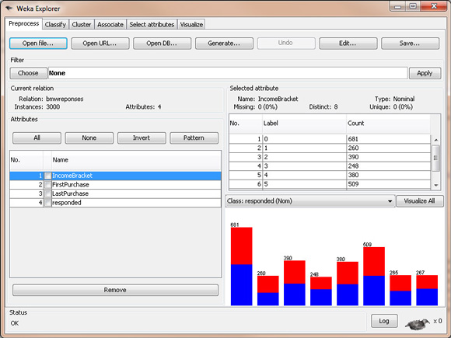
It is a data mining tool which was developed in New Zealand by the University of Waikato that implements data mining algorithms using JAVA language. WEKA is a collection of machine learning algorithms and their application to the data mining problems. These algorithms are directly applied to the dataset. WEKA supports data file in ARFF format. WEKA is open source software and hence, it is not dependent on any platform. It includes algorithms for data processing, classification, regression, clustering, association and also visualization tools.
Fig.1 Weka example image

Five important features of Weka are:
Open Source: It is released as open source software under the GNU GPL. It is dual licensed and Pentaho Corporation owns the exclusive license to use the platform for business intelligence in their own product.
Graphical Interface: It has a Graphical User Interface (GUI). This allows you to complete your machine learning projects without programming.
Command Line Interface: All features of the software can used from the command line. This can be very useful for scripting large jobs.
Java API: It is written in Java and provides a API that is well documented and promotes integration into your own applications. Note that the GNU GPL means that in turn your software would also have to be released as GPL.
Documentation: There books, manuals, wikis and MOOC courses that can train you how to use the platform effectively.
The main reason to promote Weka is because a beginner can go through the process of applied machine learning using the graphical interface without having to do any programming. This is a big deal because getting a handle on the process, handling data and experimenting with algorithms is what a beginner should be learning about, not learning yet another scripting language.
    - Tanagra:

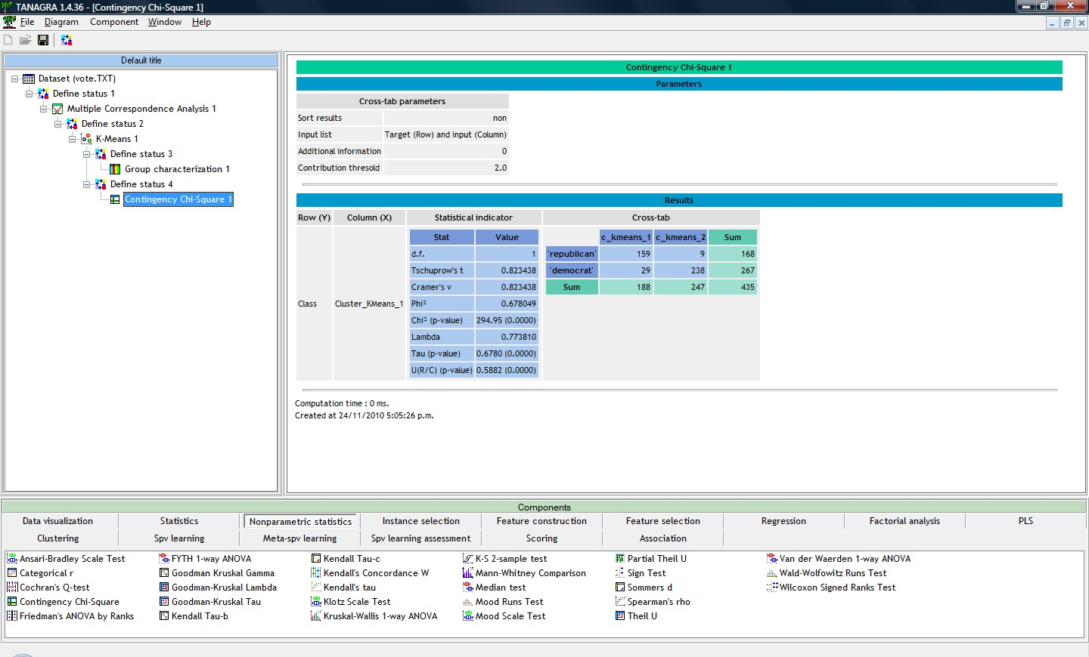
It is an open source software as researchers can access to the source code and add their own algorithms and compare their performances, if it conforms to the software distribution license. It includes several data mining algorithms from statistical learning, machine learning, data analysis and database area.
Fig.2 Tanagra example image

Tanagra works as the current data mining tools. The user can design visually a data mining process in a diagram. Each node is a statistical or machine learning technique, the connection between two nodes represents the data transfer. But unlike of the majority of the tools which are based on the workflow paradigm, Tanagra is very simplified. The treatments are represented in a tree diagram. The results are displayed in a HTML format. So it is easy to export the outputs in order to visualize the results in a browser. It is also possible to copy the result tables to a spreadsheet.
Tanagra makes a good compromise between the statistical approaches (e.g. parametric and nonparametric statistical tests), the multivariate analysis methods (e.g. factor analysis, correspondence analysis, cluster analysis, regression) and the machine learning techniques (e.g. neural network, support vector machine, decision trees, random forest)
    - MATLAB:

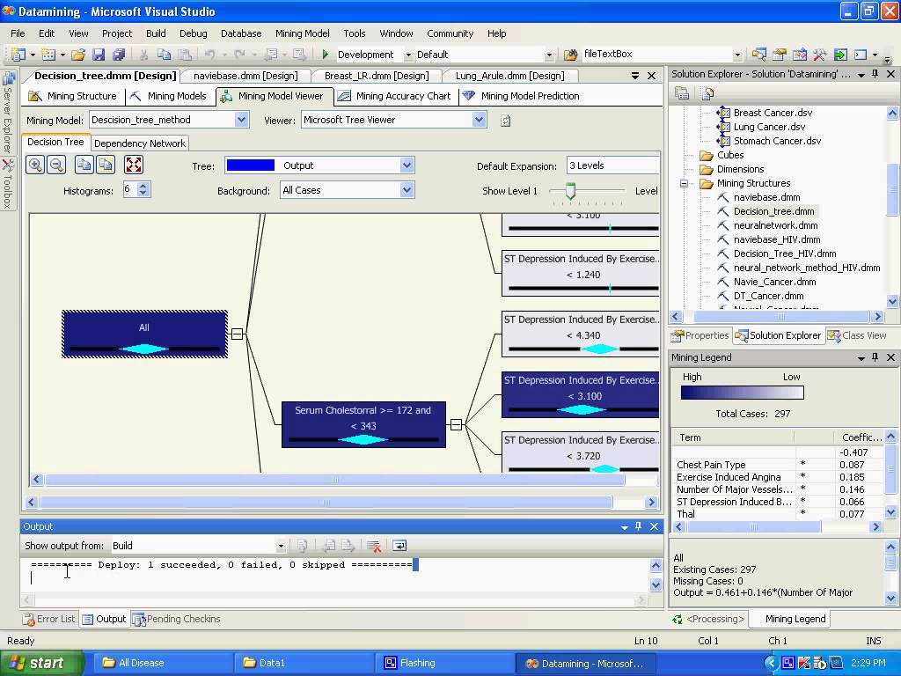
It is a data mining tool built in high level language. It provides interactive environment for visualization, numerical computation and programming. The built in math functions, language and tool explore various approaches and helps to reach a solution faster than with the spreadsheet of traditional programming languages like C,C++ and JAVA. It analyzes data, develop algorithms, and create models and applications.
Fig.3 MATLAB example image

“MATLAB has excellent built-in support for many data analysis and visualization routines,” [Murphy 2005] in particular, one of its most useful facilities is that of efficient exploratory data analysis [Vlachos 2005], which is a natural fit in the context of data mining [Hand et al. 2001]. The paper by Dwinnell [1998] discusses MATLAB in the context of fourth generation languages and highlights some important advantages of MATLAB over previous generations. It is important to understand the reasons for choosing MATLAB as our data mining tool [Paola et al. 2006] as this will allow us to raise questions of the software and have ready answers for these questions.

    - .NET Framework:


It is a software framework developed by Microsoft which runs primarily on Microsoft
Fig.4 .NET framework example image

windows. It provides secure communication and consistent applications. It provides language interoperability (each language can code written in other languages) across several programming languages.

  - Data Mining Techniques
3.2.1 J48 Technique:
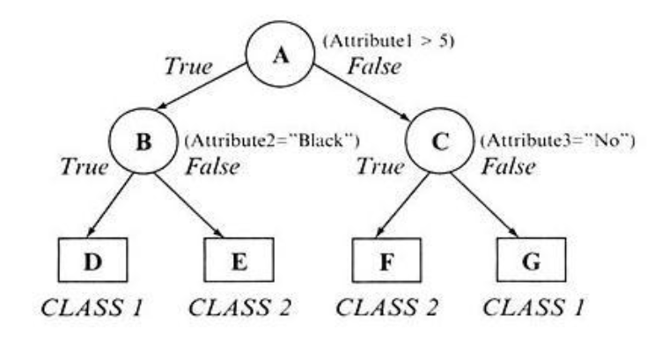
Decision tree is a kind of classifying and predicting data mining technology, belonging to inductive learning and supervised knowledge mining technology. As decision tree is advantageous in fast construction and generating easy-to interpret If-Then decision rule, it has become the most widely applied technique among numerous classification methods. Decision tree algorithm has been applied in many medical tasks, for examples, in increasing quality of dermatologic diagnosis, predicting essential hypertension, and predicting cardiovascular disease. Decision tree is one of the most popular tools for classification and prediction. Production of a decision tree is an efficient method for classification of data. This tree using a top-down strategy to build a test on each node. J48 decision tree method is the implementation of c4.5 decision tree in weka data mining tool. J48 decision tree supports continuous and discrete features. It can also manage features with missing value.
Fig.5 J48 Decision tree example
J48 is an extension of ID3. The additional features of J48 are accounting for missing values, decision trees pruning, continuous attribute value ranges, derivation of rules, etc. In the WEKA data mining tool, J48 is an open source Java implementation of the C4.5 algorithm. The WEKA tool provides a number of options associated with tree pruning. In case of potential over fitting pruning can be used as a tool for précising. In other algorithms the classification is performed recursively till every single leaf is pure, that is the classification of the data should be as perfect as possible. This algorithm it generates the rules from which particular identity of that data is generated. The objective is progressively generalization of a decision tree until it gains equilibrium of flexibility and accuracy.
    - Naïve Bayes Algorithm
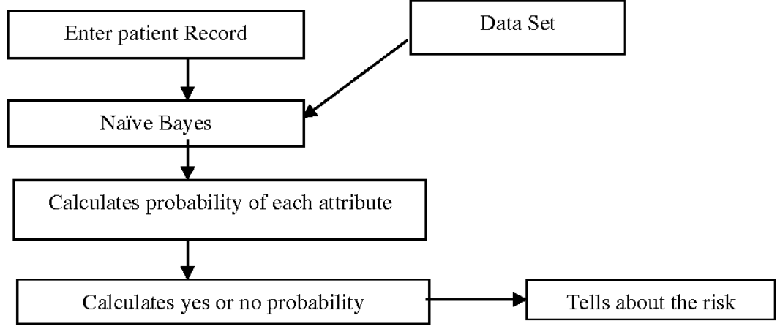
Naïve Bayes Rule is the basis for many machine learning and data mining methods. The rule (algorithm) is used to create models with predictive capabilities. It provides new ways of exploring and understanding data. A naïve Bayes classifier is a term dealing with a simple probabilistic classification based on applying Bayes theorem. In simple terms, a naïve Bayes classifier assumes that the presence (or absence) of a particular feature of a class is unrelated to the presence (or absence) of any other feature.
Fig.6 Naïve Bayes algorithm
It learns from the “evidence” by calculating the correlation between the target (i.e., dent) and other (i.e., independent) variables. Depending on the precise nature of the probability model, naive Bayes classifiers can be trained very efficiently in a supervised learning setting. Naive Bayes classifiers often work much better in many complex real-world situations than one might expect. Here independent variables are considered for the purpose of prediction or occurrence of the event. The algorithm is used to create models with predictive capabilities. It provides new ways of exploring and understanding data. For example, a patient may led to have certain symptoms. Based on the observation, Bayes' theorem can be used to compute the probability that a proposed diagnosis is correct. Bayes’ Theorem finds the probability of an event occurring given the probability of another event that has already occurred. If B represents the dependent event and A represents the prior event, Bayes theorem can be stated as follows, P (B given A) = Prob(A and B) / Prob (A) To calculate the probability of B given A, the algorithm counts the number of cases where A and B occur P (Ci/X)>P (Cj/X) for all 1< = j< = m and j!= i.

Naive Bayes algorithm is the algorithm that learns the probability of an object with certain features belonging to a particular group/class. In short, it is a probabilistic classifier. The Naive Bayes algorithm is called "naive" because it makes the assumption that the occurrence of a certain feature is independent of the occurrence of other features.
For instance, if you are trying to identify a fruit based on its color, shape, and taste, then an orange colored, spherical, and tangy fruit would most likely be an orange. Even if these features depend on each other or on the presence of the other features, all of these properties individually contribute to the probability that this fruit is an orange and that is why it is known as "naive."
As for the “Bayes” part, it refers to the statistician and philosopher, Thomas Bayes and the theorem named after him, Bayes' theorem, which is the base for Naive Bayes Algorithm.
    - Fuzzy Logic
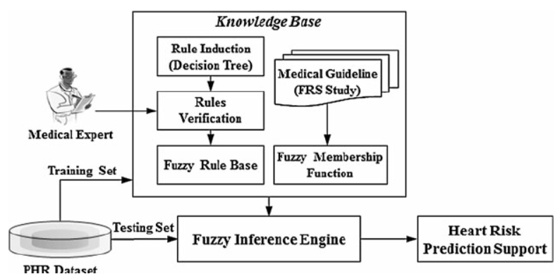
Crisp input values are transferred into fuzzy values in the stage of fuzzification. The Fuzzy values are taken into the Generating rules for Advanced Fuzzy Resolution Mechanism.
Fig.7 Fuzzy logic

Data Mining tools | Techniques | Accuracy
Weka 3.6.4 | J48 Technique | 95.56%
Weka 3.6.4 | Naïve Bayes | 92.42%
Weka | Neural network | 79.19%
TANAGRA | Fuzzy logic | 83.85%
Weka 3.6.6 | Naïve Bayes | 99.52%
TANAGRA | Decision Trees | 52.33%
.NET data mining tool | Neural Network | 96.5%
Table 2.Comparison of data mining tools with techniques and accuracy.
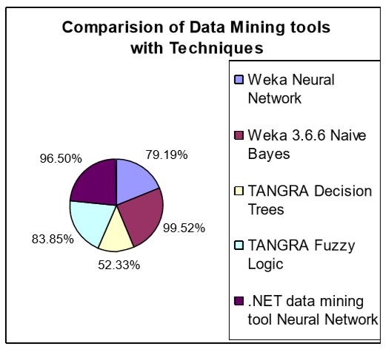
From Table 2, different versions of Weka tools, TANGRA, .Net data mining tools are discussed. When the techniques used are differ, the result will vary. When compared to other data mining tools, Weka tool gives the highest accuracy.
Fig.8 Chart 1: Comparison of Data Mining tools with techniques.

The Chart 1 is drawn for the different data mining tools with various techniques. When compared to other data mining tools, Weka 3.6.6 data mining tool is easy, and it will produce the highest accuracy. When the data mining Tool Weka 3.6.4 with J48Technique is used the accuracy is 95.56%. But at the same time, the technique Naïve Bayes is used the accuracy is 92.42%. The previous version of WEKA is used with Neural Network the accuracy is very low i.e., 79.19%. The Data Mining tool TANGARA with Fuzzy Logic is used the accuracy is 83.85%. Weka 3.6.6 with Naïve Bayes is used the accuracy is 99.52%.The data Mining Tool TANGRA with the technique Decision Tree is used, the accuracy is very low, i.e. 52.33% . .Net data mining tool is used with Neural Network, the accuracy is 96.5%.

3.3 Implementation
Naïve Bayes algorithm:
The Naïve Bayes’ algorithm makes use of 2 data sets, training set and testing set. The training set is the data set fed into the data mining tool for its reference (say Weka), and the testing set is the data set whose data needs to be classified into yes or no(the patient has heart disease or he doesn’t). A training set could look like Fig.9.
The training set can be created with a lot of research and study or it can be obtained from online portals of universities like MIT, which have open source data sets of various categories and attributes.

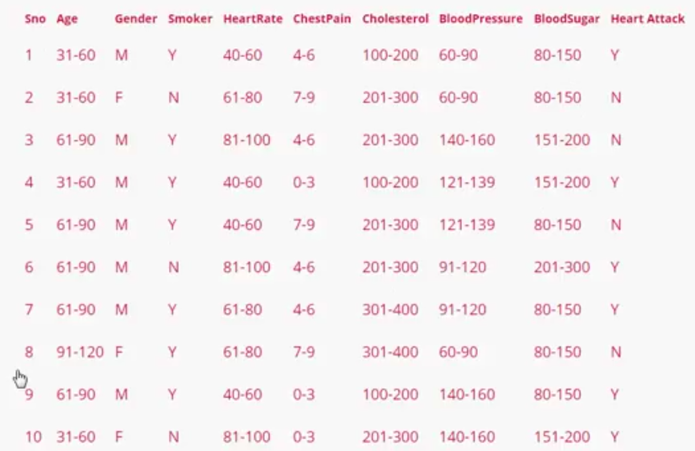

Fig.9 Training data set

The testing set, which also looks like the training set but it’s not classified yet, is fed to the data mining tool. There are web applications which take the input directly from the user as shown below, then using the training set and the Naïve Baye’s algorithm (Bayes’ Theorem finds the probability of an event occurring given the probability of another event that has already occurred. If B represents the dependent event and A represents the prior event, Bayes theorem can be stated as follows, P (B given A) = Prob(A and B) / Prob (A) To calculate the probability of B given A, the algorithm counts the number of cases where A and B occur P (Ci/X)>P (Cj/X) for all 1< = j< = m and j!= i.), it classifies whether the user has the heart disease or not(yes or no).
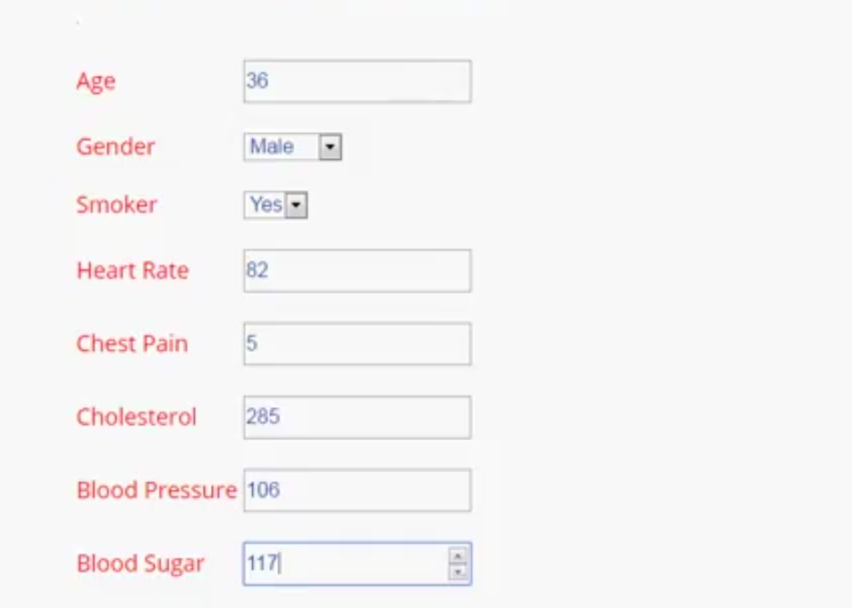

Fig.10 User input

The testing set could be in excel format or the format supported by the data mining tool. And there are web applications which have data mining tools embedded in them, so that now there is an opportunity for a user give only one input set to check whether he has the heart disease or not (Fig.10). The Naïve Bayes’ algorithm is applied to the testing set with reference to the training set and it is classified as whether the person has the disease under question or not(positive or negative).
After classification the result could be shown like Fig.11,

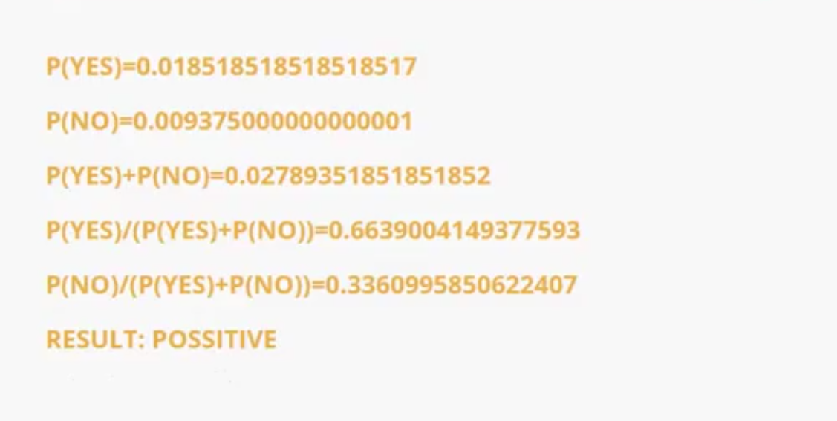
Fig.11 Output example

J48 algorithm:
The J48 algorithm also can be executed in data mining tools like Weka, which creates a Decision Tree to classify the testing data set. The decision tree is created, as shown in the figure Fig.5, for the training set and when the testing set is given, it makes use of the decision tree and classifies the set.
The data mining tools (like Weka) have several data mining algorithms already defined and ready to be implemented. The J48 algorithm can also be used in the mining tool for classification. The whole process of classification remains the same as explained in the above section about the Naïve Bayes’ algorithm in the data mining tool, only difference will be the algorithm used and the accuracy of the result.

4. APPLICATIONS IN MEDICAL FIELD

4.1 Assessing disease risks
Disease risk assessment has a great influence on prognosis and clinical intervention strategies. Rapid and accurate assessment can help clinicians determine a patient's condition with which to decide the optimal treatment strategy. Relationships between risk factors and prognosis of diseases are complex. The same risk factors can occur in many different diseases, and one disease can be composed of many risk factors. As such, the relationship between risk factors and diseases has great correlativity rather than a simple causality. Therefore, data mining can be used to assess the disease risks to find the key factors associated with the disease prognosis in order to provide effective treatment for a disease's tertiary prevention.

4.2 Supporting Clinical Diagnoses

In clinical diagnoses, doctors are often concerned with various symptoms of diseases. One disease can present different symptoms in different patients, while many diseases have the same or similar clinical manifestations. This makes it difficult to diagnose a disease, which can lead to misdiagnoses or missed diagnoses. According to published research, the average misdiagnose worldwide is 30.0%, with 27.8% occurring in China. Misdiagnosis not only leads missing the best window of opportunity for treatment, but also increases the financial burden on patients and their families, further inducing conflicts and disputes between doctors and patients. Data mining technology has brought new hope to disease diagnosis. By use of big data mining technology, a patient's previous diagnosis can be extracted, and the laboratorial results and clinical symptoms can be quickly obtained to help analyze similar manifestations. Doctors’ experiences and the advantages of data mining can be combined to provide the best chance for accurate disease diagnosis.
4.3 Predicting Disease Development
At present, disease prognosis is mainly based on the classification of the disease diagnosis or key indicators of clinical laboratory testing. The majority of diagnostic grading standards are issued by foreign authoritative medical institutions. Due to ethnic differences, these criteria can lead to errors when applied to domestic patients and can affect doctors’ judgments to some extent. In this regard, data mining technology can provide more accurate results. ANN technology is widely used in various contexts; in the medical field, it can simulate the thinking mode of the human brain and has the ability to learn, think, and memorize, allowing it to deal with complex data.

4.4 Practical drug use guidance
The US has been at the forefront of developing the application of big data mining in health and medicine. Its government applied the results of big data research in the clinical field, the representative product of which is Pillbox. A drug guidance device based on big data, Pillbox contains all the information of a variety of drugs including color, shape, dosage, and interactions with other drugs. This device is capable of providing accurate information to patients for a variety of drugs, especially for rare clinical drugs, can help patients understand drug characteristics, and offer sensible drug use guidance.

4.5 Strengthening medical management
Data mining has a brilliant future in medical management. It can help to analyze medical operation indicators of hospitals for a period of time, including medical information management, medical quality management, medical supplies management, financial management, medical dispute management, doctors work performance, hospital management, decision-making management, hospital resource management, etc., to help hospital administrators provide data support for medical decision-making.

4.6 Benefiting evidence-based medicine
Evidence-based medicine has become the main direction of clinical work. For each specific clinical issue, medical workers can search the latest research progress to solve the problem, which will avoid rashness caused by experience. Data mining technology can take large amounts of evidence-based on medicine research into the data warehouse with the innovation of the data mining technology; then, a more efficient search method will be conducted and more accurate search results will be provided.

5. CONCLUSION

The objective of this work is to provide a study of Heart Diseases with various Data Mining tools with various versions. When compared to other data mining tools, Weka 3.6.6 with Naïve Bayes Technique is simple, easy, and it will produce the highest accuracy. Weka Tool is very easy to implement. It will definitely help the medical practitioners to predict the heart disease. This tool will protect the lives of the patients. It will also help the researcher to select the appropriate tool.

6. REFERENCES

1. K.Manimekalai, A Proficient Heart Disease Prediction Method Using Different Data Mining Tools, IJESC, DOI 10.4010/2016.627, ISSN 2321 3361, 2016.
2. Abhishek taneja, Heart Disease Prediction System Using Data Mining Techniques, Oriental Scientific Publishing Co., India, 2013.
3. Rashedur M. Rahman, Farhana Afroz, Comparison of Various Classification Techniques Using Different Data Mining Tools for Diabetes Diagnosis, Journal of Software Engineering and Applications, 2013.
4.Nidhi Bhatla and Kiran Jyoti, “An Analysis of Heart Disease Prediction using Different Data Mining Techniques”, International Journal of Engineering Research & Technology (IJERT), ISSN: 2278- 0181,Vol. 1 Issue 8, October – 2012.
5. Humar Kahramanli, Novruz Allahverdi, Design of a hybrid system for the diabetes and heart diseases, Elsevier, 2008.
6. K.Manimekalai, “A Review on Prediction of Heart Diseases by Comparing Risk Factors in Data Mining”, IJCSIT, ISSN:0975- 9646, Vol 7(1), 2016, 396-398.
7. K.Manimekalai, “Prediction of Heart Diseases using Data Mining Techniques”, IJIRCCE, Vol 4, Issue 2, February 2016, ISSN: 2320- 9801.
8. Hlaudi Daniel Masethe, Mosima Anna Masethe, “Prediction of Heart Disease using Classification Algorithms”, Proceedings of the World Congress on Engineering and Computer Science 2014 Vol II WCECS 2014, 22-24 October, 2014, San Francisco, USA.
9. Ms.Rupali R.Patil, “Heart Disease Prediction System using Naïve Bayes and Jelinek-mercer smoothing”, International Journal Advanced Research in Computer and Communication Engineering Vol. 3, Issue 5, May 2014.
10. Abhishek Taneja, “Heart Disease Prediction System Using Data Mining Techniques”, Oriental Journal of computer Science & Technology , An International Open Free Access, Peer Reviewed Research Journal.
11. B.Venkatalakshmi, M.V Shivsankar, “Heart Disease Diagnosis Using Predictive Data mining”, International Journal of Innovative Research in Science, Engineering and Technology, Volume 3, Special Issue 3, March 2014.

